Model Aeronautics
Association of Canada
Unit 9, 5100 South Service Road
Burlington, ON L7L 5H4
Attn: Linda Patrick cc Harry Ells - FAI Committee Chairman
cc Frank Klenk - Chair of Chairs
Hi Linda,
The 2019 F2B Team Trials were held on Saturday July 27th at Centennial Park in Toronto Ontario. The weather was very hot and humid but perfect for the event with just a light 10 km/hr breeze blowing away from the sun.
The 2020 F2B World Championships are scheduled for August 9-15 2020 in Wloclawek Poland.
The Team Trials were organized by CD John McFayden 14681L and judging was handled by three experienced F2B competitors namely Chris Brownhill 3797L, Len Bourel 14801 and John McFayden 14681L. Tabulator was Naomi Macklem 82384.
There were 4 entrants in the Team Trials, Konstantin Bajaikine 61045, Peter Hanson 65002, Pat Mackenzie 8177L and Dwayne Donnelley 44334. Each pilot flew three flights with their two best scores added together per FAI standard.
The results were as follows:
Pilot | Score
Konstantin Bajaikine | 1,111.3 | 1 st
Peter Hanson | 1,103.9 | 2 nd
Pat Mackenzie | 1,069.8 | 3 rd
Dwayne Donnelley | 922.0 | Alternate

Enclosed is a cheque for $100 for the FAI Travel Fund collected at this event.

Respectfully submitted,

John McFayden 14681L
Committee Chair, Control Line Precision Aerobatics
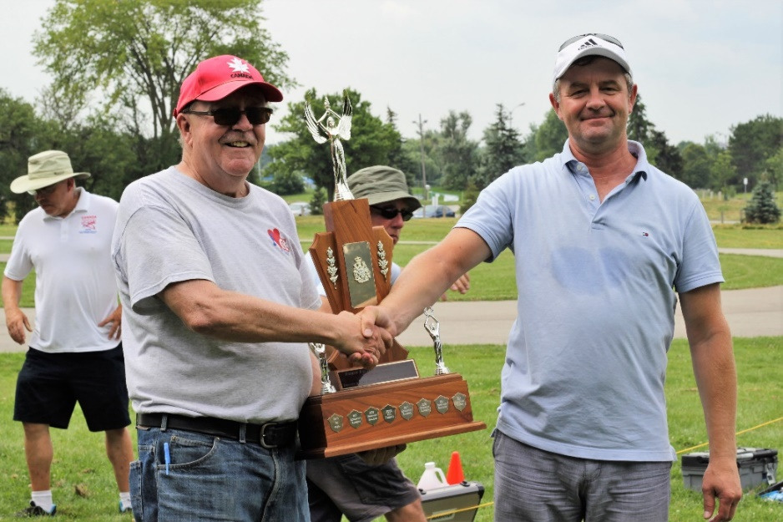

John McFayden (L) presenting Konstantin Bajaikine (R) the Rob Kolarik Trophy as the 2019 F2B Team Trials Champion.

Check out the following link to the Balsa Beavers Model Flying Club website for a complete photo album of the Trials.
http://www.balsabeavers.com/albums/album_viewer.php?a=109
